Practical No. 1
Definition : Write a program to demonstrate basic input and output operations in Python.
Aim/ Objective:
- To understand how to accept input from the user in Python.
- To display output using the print() function.
- To perform basic operations on user-provided data.
- To understand basic Python syntax for input and output.
Source Code:
# Program 1: Basic Input and Output Operations
name = input("Enter your name: ")
age = int(input("Enter your age: "))
height = float(input("Enter your height in meters: "))

print("\n--- User Profile ---")
print(f"Name : {name}")
print(f"Age : {age} years old")
print(f"Height : {height} m")

Output:
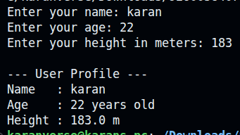
Conclusion:
The program successfully demonstrates the basic input and output operations in Python. It shows how to accept data from the user using input(), convert input into appropriate data types, store values in variables, perform a basic arithmetic operation, and display the results using print()

Practical No. 2

Definition : Write a program to illustrate the use of different data types and type casting.
Aim/ Objective:
- To understand different data types available in Python.
- To learn how to declare and use different types of data.
- To understand the concept of type casting in Python.
- To convert data from one type to another using type casting functions.
- To perform basic operations using different data types.
Source Code:
# Program 2: Data Types and Type Casting

num_int = 42
num_float = 3.14159
text_str = "100"
flag_bool = True
colors_list = ["red", "green", "blue"]

print("--- Data Types ---")
print(f"{num_int} is of type:", type(num_int))
print(f"{num_float} is of type:", type(num_float))
print(f"'{text_str}' is of type:", type(text_str))
print(f"{flag_bool} is of type:", type(flag_bool))
print(f"{colors_list} is of type:", type(colors_list))

print("\n--- Type Casting ---")

str_to_int = int(text_str)
str_to_float = float(text_str)
print(f"String '{text_str}' -> Int: {str_to_int} (Type: {type(str_to_int).__name__})")
print(f"String '{text_str}' -> Float: {str_to_float} (Type: {type(str_to_float).__name__})")
float_to_int = int(num_float)
print(f"Float {num_float} -> Int: {float_to_int} (Type: {type(float_to_int).__name__})")

zero_bool = bool(0)
num_bool = bool(5)
print(f"bool(0) is {zero_bool}, while bool(5) is {num_bool}")

char_list = list("Python")
print(f"String 'Python' -> List: {char_list}")

Output:
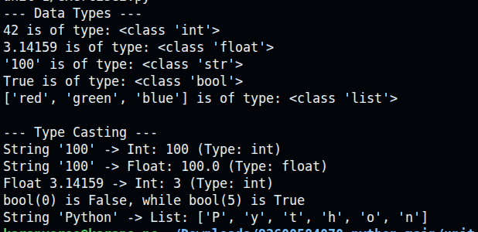
Conclusion:
The program successfully demonstrates the use of different data types and type casting in Python. It shows how to use various data types such as integer, float, string, and boolean, and how to convert data from one type to another using type casting functions. It helps in understanding how Python handles different types of data and performs basic operations on them.
Practical No. 3
Definition :Write a program to perform arithmetic relational and logical operations using Python operators.
Aim/ Objective:
- To understand the use of arithmetic, relational, and logical operators in Python.
- To perform basic arithmetic calculations using Python operators.
- To compare values using relational operators.
- To understand and perform logical operations using logical operators.
- To understand how different Python operators are used in programs.
Source Code:
# Program 3: Arithmetic, Relational, and Logical Operators

a = 15
b = 4

print("--- Arithmetic Operators ---")
print(f"Addition ({a} + {b}) = {a + b}")
print(f"Subtraction ({a} - {b}) = {a - b}")
print(f"Multiplication ({a} * {b}) = {a * b}")
print(f"Division ({a} / {b}) = {a / b}")
print(f"Floor Division ({a} // {b}) = {a // b}")
print(f"Modulus ({a} % {b}) = {a % b}")
print(f"Exponentiation ({a} ** {b}) = {a ** b}")
print("\n--- Relational Operators ---")
print(f"{a} == {b} : {a == b}")
print(f"{a} != {b} : {a != b}")
print(f"{a} > {b} : {a > b}")
print(f"{a} < {b} : {a < b}")
print(f"{a} >= {b} : {a >= b}")
print(f"{a} <= {b} : {a <= b}")
x = True
y = False

print("\n--- Logical Operators ---")
print(f"x = {x}, y = {y}")
print(f"x and y : {x and y}")
print(f"x or y : {x or y}")
print(f"not x : {not x}")

Output:
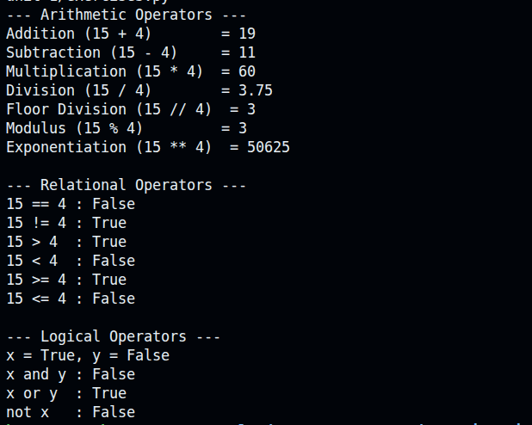
Conclusion:
The program successfully demonstrates arithmetic, relational, and logical operations using Python operators. It shows how to perform basic mathematical calculations, compare values, and combine conditions using logical operators. This helps in understanding the use of different operators in Python programs.
Practical No. 4
Definition : Write a program to demonstrate string operations including slicing formatting and built-in string functions.
Aim/ Objective:
- To understand and perform basic string operations in Python.
- To learn how to access and manipulate strings using indexing and slicing.
- To understand string formatting and its use in Python programs.
- To use built-in string functions for performing various operations on strings.
- To develop a basic understanding of string manipulation in Python.

Source Code:
# Program 4: String Operations

text = " Hello, Python Programming World! "

clean_text = text.strip() # Removing leading/trailing whitespace first
print("--- String Slicing ---")
print(f"Original Text : '{clean_text}'")
print(f"First 5 chars (0:5) : '{clean_text[:5]}'")
print(f"Substring (7:13) : '{clean_text[7:13]}'")
print(f"Last 6 chars (-6:) : '{clean_text[-6:]}'")
print(f"Reversed String (::-1): '{clean_text[::-1]}'")
print(f"Every 2nd char (::2) : '{clean_text[::2]}'")

print("\n--- String Formatting ---")
name = "Dev"
score = 94.5678

print(f"f-string : Student {name} scored {score:.2f}%")

print("str.format : Student {} scored {:.1f}%".format(name, score))
print("%% operator : Student %s scored %.2f%%" % (name, score))

print("\n--- Built-in String Methods ---")
raw_msg = "python programming is versatile"

print(f"Uppercase : '{raw_msg.upper()}'")
print(f"Title Case : '{raw_msg.title()}'")
print(f"Replace Word : '{raw_msg.replace('python', 'Java')}'")
print(f"Find Index : 'programming' starts at index {raw_msg.find('programming')}")

words = raw_msg.split()
print(f"Split to List : {words}")

joined_str = "-".join(words)
print(f"Joined with '-' : '{joined_str}'")

Output:
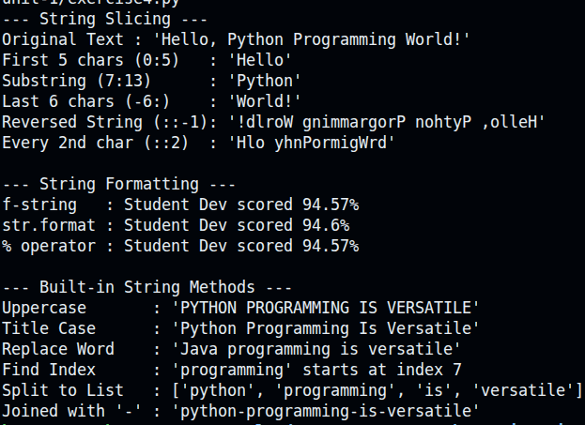

Conclusion:
The program successfully demonstrates various string operations in Python, including indexing, slicing, formatting, and the use of built-in string functions. It shows how strings can be accessed, modified, formatted, and manipulated using different Python techniques.
Practical No. 5
Definition : Write a program to create and manipulate lists using indexing slicing and list comprehensions.
Aim/ Objective:
- To understand the concept of lists in Python.
- To learn how to create and manipulate lists.
- To access list elements using indexing.
- To perform operations on lists using slicing.
- To understand and use list comprehensions for creating lists efficiently.
Source Code:
# Program 5: List Creation, Indexing, Slicing, and List Comprehensions

numbers = [10, 20, 30, 40, 50, 60, 70, 80, 90, 100]
print("Original List:", numbers)

print("\n--- Indexing ---")
print("First element (index 0) :", numbers[0])
print("Last element (index -1) :", numbers[-1])
print("Fifth element (index 4) :", numbers[4])
print("\n--- Slicing ---")
print("First 4 elements (0:4) :", numbers[:4])
print("Elements from index 3 to 7:", numbers[3:8])
print("Every second element (::2):", numbers[::2])
print("Reversed list (::-1) :", numbers[::-1])
print("\n--- List Comprehensions ---")
squares = [x**2 for x in range(1, 11)]
print("Squares (1-10):", squares)

even_doubled = [x * 2 for x in numbers if x % 20 == 0]
print("Multiples of 20 doubled:", even_doubled)

fruits = ["apple", "banana", "cherry", "date"]
first_letters = [fruit[0].upper() for fruit in fruits]
print("First letters uppercase:", first_letters)

Output:
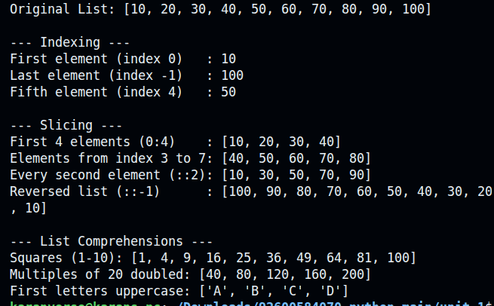
Conclusion:
The program successfully demonstrates how to create and manipulate lists in Python. It shows how to access elements using indexing, extract elements using slicing, and create new lists efficiently using list comprehensions. This helps in understanding the basic operations and flexibility of Python lists.
Practical No. 6
Definition : Write a program to illustrate the use of tuples and sets with basic operations.

Aim/ Objective:
- To understand the concept of tuples and sets in Python.
- To learn how to create and access elements of tuples.
- To perform basic operations on tuples and sets.
- To understand the properties and differences between tuples and sets.
- To learn how sets are used to store unique elements and perform set operations.
Source Code:
# Program 6: Tuples and Sets Operations

print("--- Tuple Operations ---")
point = (10, 25, 50)
fruits_tuple = ("apple", "banana", "cherry", "apple")

print("Tuple:", fruits_tuple)
print("Count of 'apple':", fruits_tuple.count("apple"))
print("Index of 'banana':", fruits_tuple.index("banana"))
x, y, z = point
print(f"Unpacked Point coordinates: x={x}, y={y}, z={z}")

print("\n--- Set Operations ---")
set_a = {1, 2, 3, 4, 5}
set_b = {4, 5, 6, 7, 8}

print("Set A:", set_a)
print("Set B:", set_b)
print("\nUnion (A | B) :", set_a.union(set_b))
print("Intersection (A & B) :", set_a.intersection(set_b))
print("Difference (A - B) :", set_a.difference(set_b))
print("Symmetric Diff (A ^ B):", set_a.symmetric_difference(set_b))

set_a.add(10)
set_a.discard(2)
print("\nSet A after adding 10 and removing 2:", set_a)
small_set = {1, 3}
print(f"{small_set} is subset of Set A?", small_set.issubset(set_a))

Output:
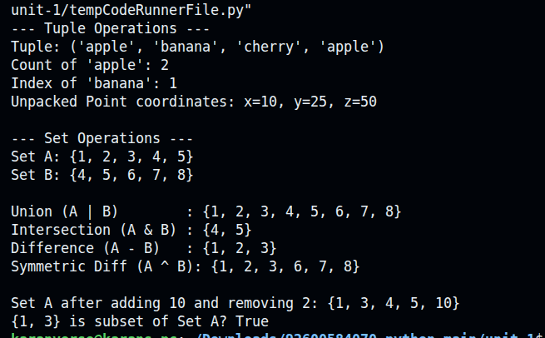
Conclusion:
The program successfully demonstrates the use of tuples and sets in Python. It shows how to create, access, and perform basic operations on tuples and sets. It also helps in understanding the differences between tuples and sets and their use for storing and managing data.

Practical No. 7
Definition : Write a program to create a dictionary and demonstrate dictionary methods and iteration.
Aim/ Objective:
- To understand the concept of dictionaries in Python.
- To learn how to create and access key-value pairs in a dictionary.
- To demonstrate various built-in dictionary methods.
- To learn how to add, update, and remove dictionary elements.
- To understand how to iterate through dictionary keys, values, and items.
Source Code:
# Program 7: Dictionary Creation, Methods, and Iteration

# 1. Creating a dictionary
student = {
"name": "Alex",
"age": 20,
"course": "Computer Science",
"gpa": 3.8
}

print("Initial Dictionary:\n", student)

# 2. Accessing & Adding/Updating elements
print("\n--- Access & Modification ---")
print("Name (using key) :", student["name"])
print("GPA (using get()) :", student.get("gpa"))
print("Grade (missing key):", student.get("grade", "Not Assigned")) # Default fallback

# Updating existing key & adding new key
student["gpa"] = 3.9
student["email"] = "alex@example.com"
print("Updated Dictionary:\n", student)

# 3. Dictionary Iteration
print("\n--- Iteration Techniques ---")

print("Keys:")
for key in student.keys():
print(f" - {key}")

print("\nValues:")
for value in student.values():
print(f" - {value}")

print("\nKey-Value Pairs (Items):")
for key, value in student.items():
print(f" {key:<10} : {value}")

# 4. Dictionary Comprehension
numbers = [1, 2, 3, 4, 5]
squares_dict = {x: x**2 for x in numbers}
print("\nDictionary Comprehension (x: x^2):", squares_dict)

Output:
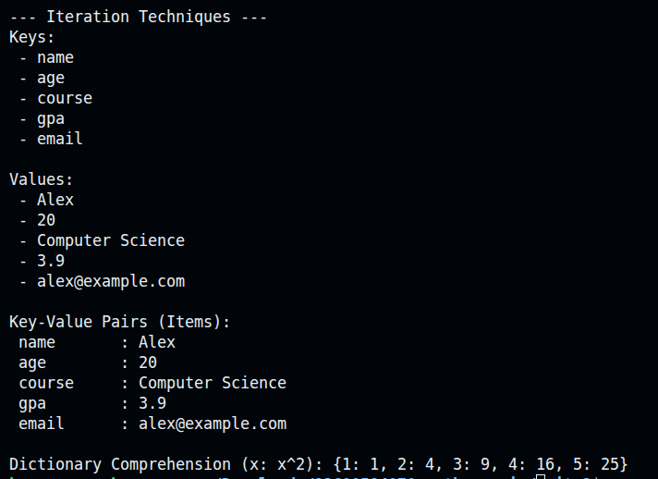

Conclusion:
The program successfully demonstrates how to create and manipulate dictionaries in Python. It shows the use of different dictionary methods to add, update, and remove elements, and demonstrates how to iterate through keys, values, and key-value pairs. This helps in understanding the efficient use of dictionaries for storing and managing data.

Practical No. 8
Definition : Write a program to explain mutable and immutable objects in Python.
Aim/ Objective:
- To understand the concept of mutable and immutable objects in Python.
- To learn the difference between mutable and immutable data types.
- To demonstrate how mutable objects can be changed after creation.
- To demonstrate how immutable objects cannot be changed after creation.
- To understand the behavior of different Python objects during modification.
Source Code:
# Program 8: Explaining Mutable vs Immutable Objects

print("=== 1. IMMUTABLE OBJECTS (Integers, Strings, Tuples) ===")
x = 100
print(f"Initial x = {x}, Memory ID: {id(x)}")

x = x + 1
print(f"Updated x = {x}, Memory ID: {id(x)} <-- ID changed!")

text = "Hello"
print(f"\nInitial text = '{text}', Memory ID: {id(text)}")
text += " World"
print(f"Updated text = '{text}', Memory ID: {id(text)} <-- ID changed!")

print("\n=== 2. MUTABLE OBJECTS (Lists, Dictionaries, Sets) ===")

my_list = [1, 2, 3]
print(f"Initial list = {my_list}, Memory ID: {id(my_list)}")

my_list.append(4)
my_list[0] = 99
print(f"Modified list= {my_list}, Memory ID: {id(my_list)} <-- ID remains SAME!")
alias_list = my_list
alias_list.append(500)
print("\nAdded 500 to 'alias_list':")
print(f"my_list is now : {my_list}")
print(f"alias_list is now: {alias_list}")

Output:
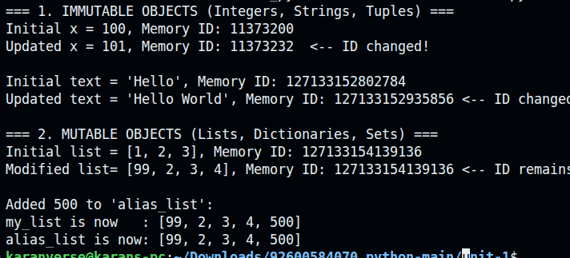
Conclusion:
The program successfully demonstrates the concept of mutable and immutable objects in Python. It shows that mutable objects can be modified after creation, while immutable objects cannot be changed. This helps in understanding how different Python data types behave when their values are modified.
Practical No. 9
Definition : Write a program to define and use user-defined functions with different types of arguments.
Aim/ Objective:
- To understand the concept of user-defined functions in Python.
- To learn how to define and call functions in a Python program.
- To understand different types of function arguments.
- To demonstrate the use of positional, keyword, default, and variable-length arguments.
- To understand how functions improve code reusability and organization.
Source Code:
# Program 9: User-Defined Functions and Argument Types

def greet_user(name, greeting="Hello", punctuation="!"):
"""Demonstrates positional & default parameters."""
return f"{greeting}, {name}{punctuation}"

def calculate_summary(title, *scores, **metadata):
"""
title : Positional arg
*scores : Gathers extra positional arguments into a tuple
**metadata: Gathers extra keyword arguments into a dictionary
"""
total = sum(scores)
avg = total / len(scores) if scores else 0

print(f"--- {title} ---")
print(f"Scores Tuple (*args) : {scores}")
print(f"Total: {total}, Average: {avg:.2f}")

print("Metadata Dict (**kwargs):")
for key, value in metadata.items():
print(f" - {key}: {value}")
msg1 = greet_user("Alice")
print(msg1)
msg2 = greet_user(greeting="Welcome", name="Bob", punctuation="!!!")
print(msg2)

print()
calculate_summary(
"Exam Report",
85, 90, 78, 92, 88, # *args (scores)
student="Charlie", term="Fall", year=2026 # **kwargs (metadata)
)

Output:
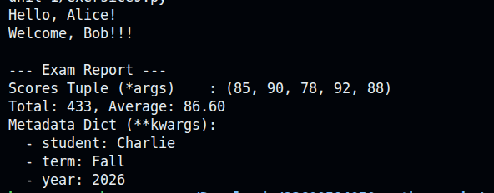
Conclusion:
The program successfully demonstrates how to define and use user-defined functions in Python. It shows the use of different types of arguments, including positional, keyword, default, and variable-length arguments. This helps in understanding how functions make programs more organized, reusable, and easier to manage.
Practical No. 10
Definition : .Write a program to demonstrate recursion using factorial or Fibonacci series.
Aim/ Objective:
- To understand the concept of recursion in Python.
- To learn how a function can call itself to solve a problem.
- To demonstrate recursion using factorial or Fibonacci series.
- To understand the use of a base condition in recursive functions.
- To develop logical thinking and problem-solving skills using recursion.
Source Code:
# Program 10: Demonstrating Recursion using Factorial and Fibonacci Series

def factorial(n):
if n < 0:
return "Factorial is not defined for negative numbers."
elif n == 0 or n == 1: # Base case
return 1
else: # Recursive step
return n * factorial(n - 1)

def fibonacci(n):
if n < 0:
return "Invalid input"
elif n == 0: # Base case 1
return 0
elif n == 1: # Base case 2
return 1
else: # Recursive step
return fibonacci(n - 1) + fibonacci(n - 2)

if __name__ == "__main__":

print("=== 1. Factorial Demonstration ===")
num = 5
result = factorial(num)
print(f"Factorial of {num} ({num}!): {result}")

print("\n" + "=" * 40 + "\n")
print("=== 2. Fibonacci Series Demonstration ===")
terms = 8
print(f"First {terms} terms of the Fibonacci series:")

fib_series = [fibonacci(i) for i in range(terms)]
print("Series:", " -> ".join(map(str, fib_series)))

Output:
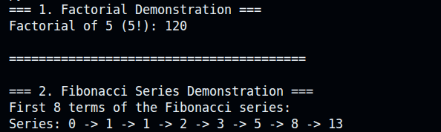
Conclusion:
The program successfully demonstrates the concept of recursion in Python using factorial or Fibonacci series. It shows how a function can call itself repeatedly until a base condition is reached. This helps in understanding recursive functions and their use in solving problems efficiently.

